Where to find her Art:  - https://www.facebook.com/RichesRoad/info  - http://www.saatchiart.com/Riches_road  - http://www.redbubble.com/people/richesroad  - http://www.pinterest.com/sara_louise/riches-road-art/  Contact her:  Address: Mt. Walker Rd. Narembeen, Western Australia 6369  Phone: +618 9064 7382  Email: fatbooks@gmail.com  Riches Road |  |  | Sara Riches  Riches Road  - Katie Perez

About Sara:  -----------------------------------------------------------------------------------  How many kids does Sara have? ______________  Where does Sara live?  ____________________________________________________  Is she married? (Circle)  YES NO  How many days a week does she draw? (Circle)  1 3 5 7 0  How old was she when she started her career? (Circle)  16 25 32 19 12 |  | What mediums does she use?  What elements do you see?  What stands out to you?  ________________________________________________________________________________________________________________________________________________________________________________________________________________________________________________________________________________________________________________________________________________________________________
2

Describe each piece:  Materials, expressions, feelings, elements.  ____________________________________________________________________________________________________________________________________________________________________________________________________________________________________________________________________________________________________________________  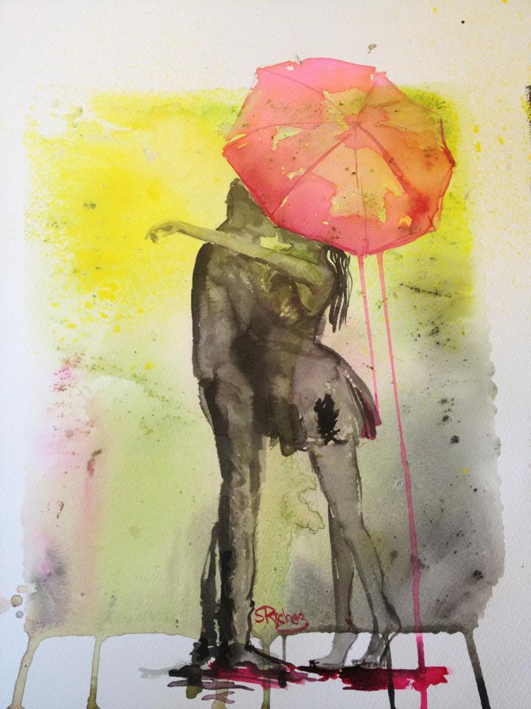  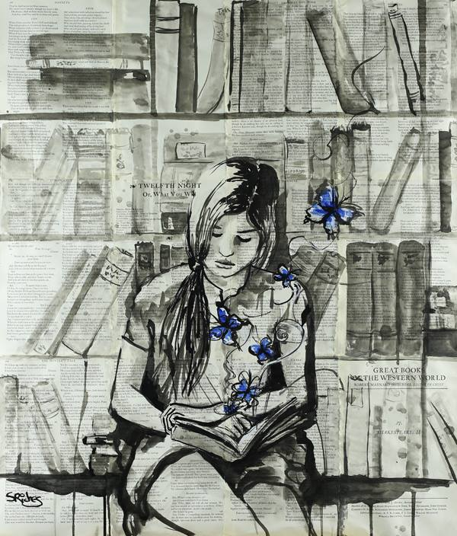  _______________________________________________________________________________________________________________________________________________________________________________________________________________________________________________________________________________________________________________________________ | 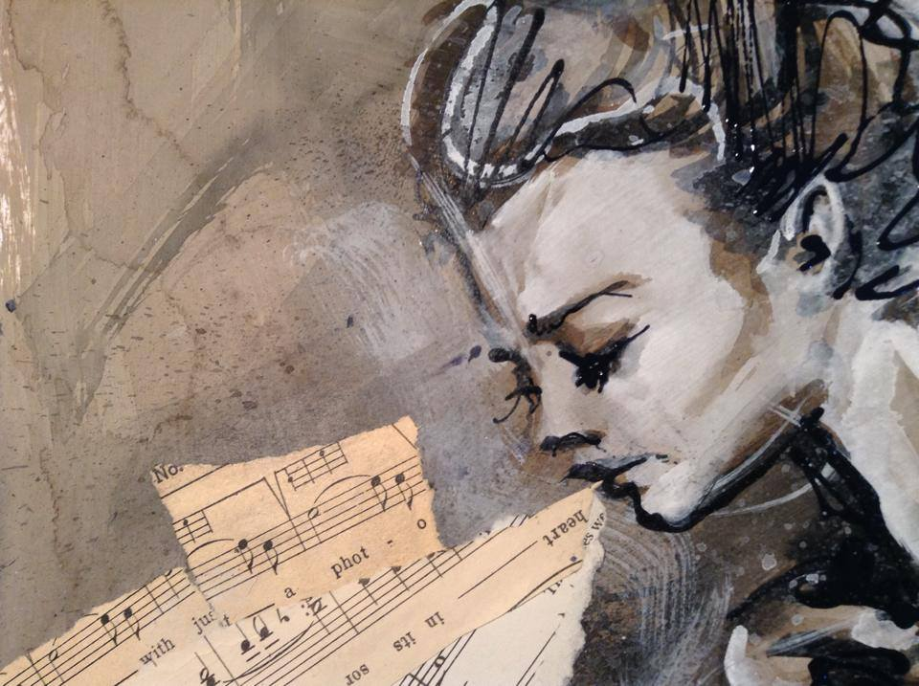  __________________________________________________________________________________________________________________________________________________________________________________________________________________________________________________________________________________________________________________________________________ |  | 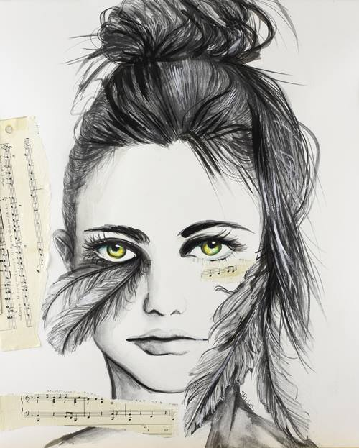  ________________________________________________________________________________________________________________________________________________________________________________________________________________________________________________________________________________________________________________________________________________
6 |  |  | 3

Terms:  ---------------------------------------------------------------------------------------------  GOUACHE:  Opaque watercolors used for illustrations.  MEDIUM:  The liquid in which pigments are suspended. Also a material chosen by the artist for working. Plural is media.  MIXED MEDIA:  In drawing and painting this refers to the use of different media in the same picture.  TINT:  Term for a color lightened with white. Also, in a mixture of colors, the tint is the dominant color.  VALUE:  The relative lightness or darkness of a hue. Black is low value. White is a high value.  VOLUME:  The space that a object or figure fills in a drawing or painting.  WATERCOLOR:  A technique of painting using a binder made from a water-soluble gum. Watercolors can be transparent or opaque. |  | What is your favorite piece by her? Why?  ____________________________________________________________________________________________________________________________________________________________________________________  How does her art make you feel?  ___________________________________________________________________________________________________________________________________________________________________________________________________
4

