STEP BY STEP TUTORIAL FOR SKTCHY APP
How to Create a Profile:
- SIGN UP, either with your email or facebook
- Upload a profile photo by pressing the photo picture on your profile page.
On the bottom of the page you will see a bar with a house, earth, lightning bolt, bubble with a star in the middle, and symbol of a person.

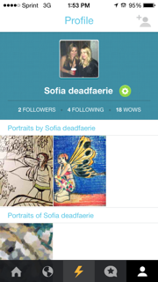 ↵
⬆
House tab will show you the latest uploads from artists you are following, as well as the latest trending artworks.
If you swipe the picture you will see the original portrait.
Example: 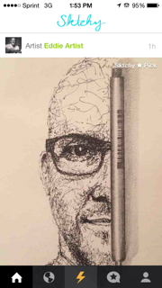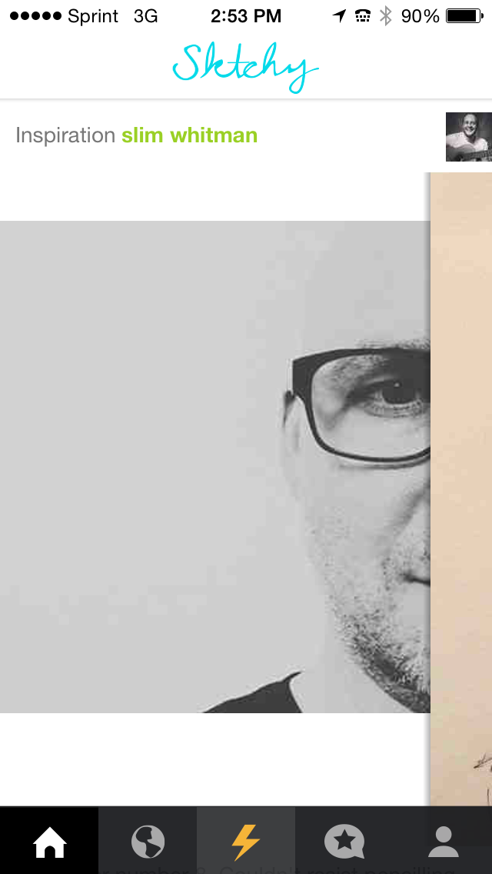

Discover tab is where you can see works of art made by other users, and find other artists using hashtags or typing in the artist name.
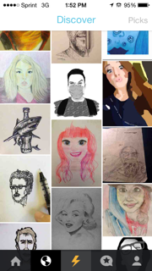
⬆

Lightning Bolt tab is where you can choose a photo to upload and find a photo uploaded by other users to be inspired by.

- Search for a portrait of someone you want to draw.
- To add a photo press the plus sign on the top right.
On the top left you will see your Queue, which is where all the photos you liked will be stored.
-When you see a photo you like, it will automatically be added to your Queue.
              
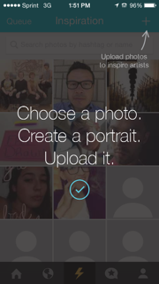 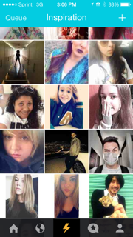
⬆

Star tab is your activity page. You can see who “wowed” your recent photo, who started following you, and if someone made a portrait of you. 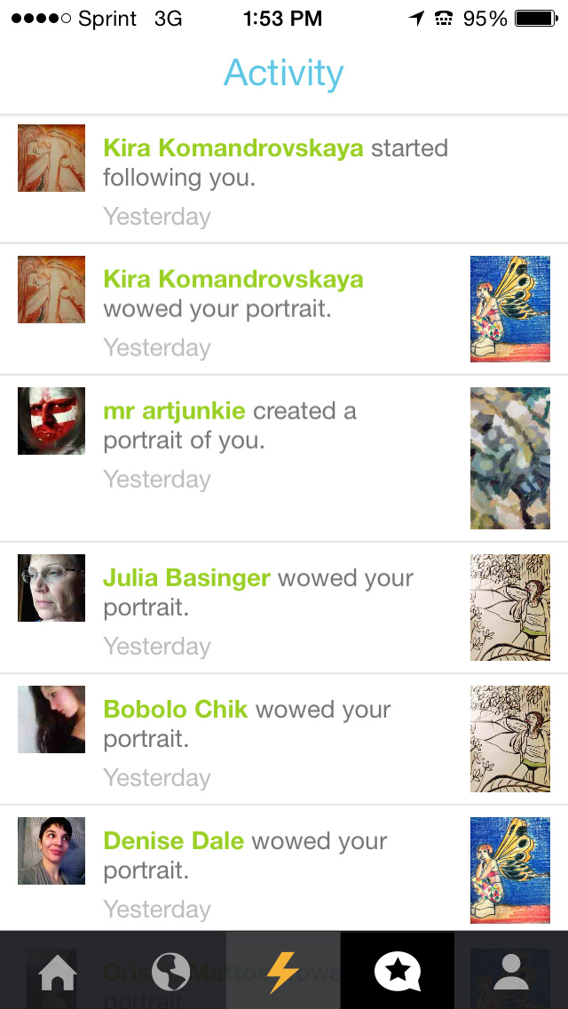

TO UPLOAD COMPLETED ARTWORK TO SKTCHY:

1. GO TO YOUR QUEUE UNDER THE LIGHTNING BOLT TAB
2. PICK THE PHOTO YOU WANT TO DRAW
3. CREATE YOUR OWN RENDITION OF THE PORTRAIT
4. TAKE A PHOTO OF YOUR ARTWORK
5. GO BACK TO YOUR QUEUE AND SELECT THE CORRECT PHOTO
6. PRESS THE BUTTON ON THE BOTTOM RIGHT THAT SAYS UPLOAD PORTRAIT.
7. CHOOSE THE PHOTO FROM YOUR LIBRARY
8. YOUR ARTWORK WILL AUTOMATICALLY BE ATTACHED TO THE ORIGINAL PHOTO.

